Meta-Analytic Results Split by PTSD Diagnosis in Study

Table 1.

*No PTSD Diagnosis or no information about diagnoses*

|  |  |  |
| --- | --- | --- |
| Model | Fixed Effects | Random Effects |
| Overall Model | 0.307  [0.269; 0.346] | 0.318  [0.234; 0.396] |
| *Z* value | 15.75, *p* < .001 | 7.95, *p* < .001 |
| *p* – Uniform | 0.538  [0.412, 0.663] | - |
| PET | 0.240  [0.124, 0.357] | - |
| PEESE | 0.280  [0.214, 0.347] | - |
| Selection Models | 0.307  [0.252, 0.361] | 0.392  [0.251, 0.532] |
| Trim and Fill | 0.307  [0.269, 0.346] | 0.318  [0.240, 0.396] |

Homogeneity: *Q*(85) = 325.27, *p* < .001, *I2* = 73.9 [67.8; 78.8]

Power:

* Original study characteristics: *M* = .45, *SD* = .35
  + Percent over 80%: 25.6
* Based on random effects: *M* = .38, *SD* = .21
  + Percent over 80%: 5.8

*p* – curve

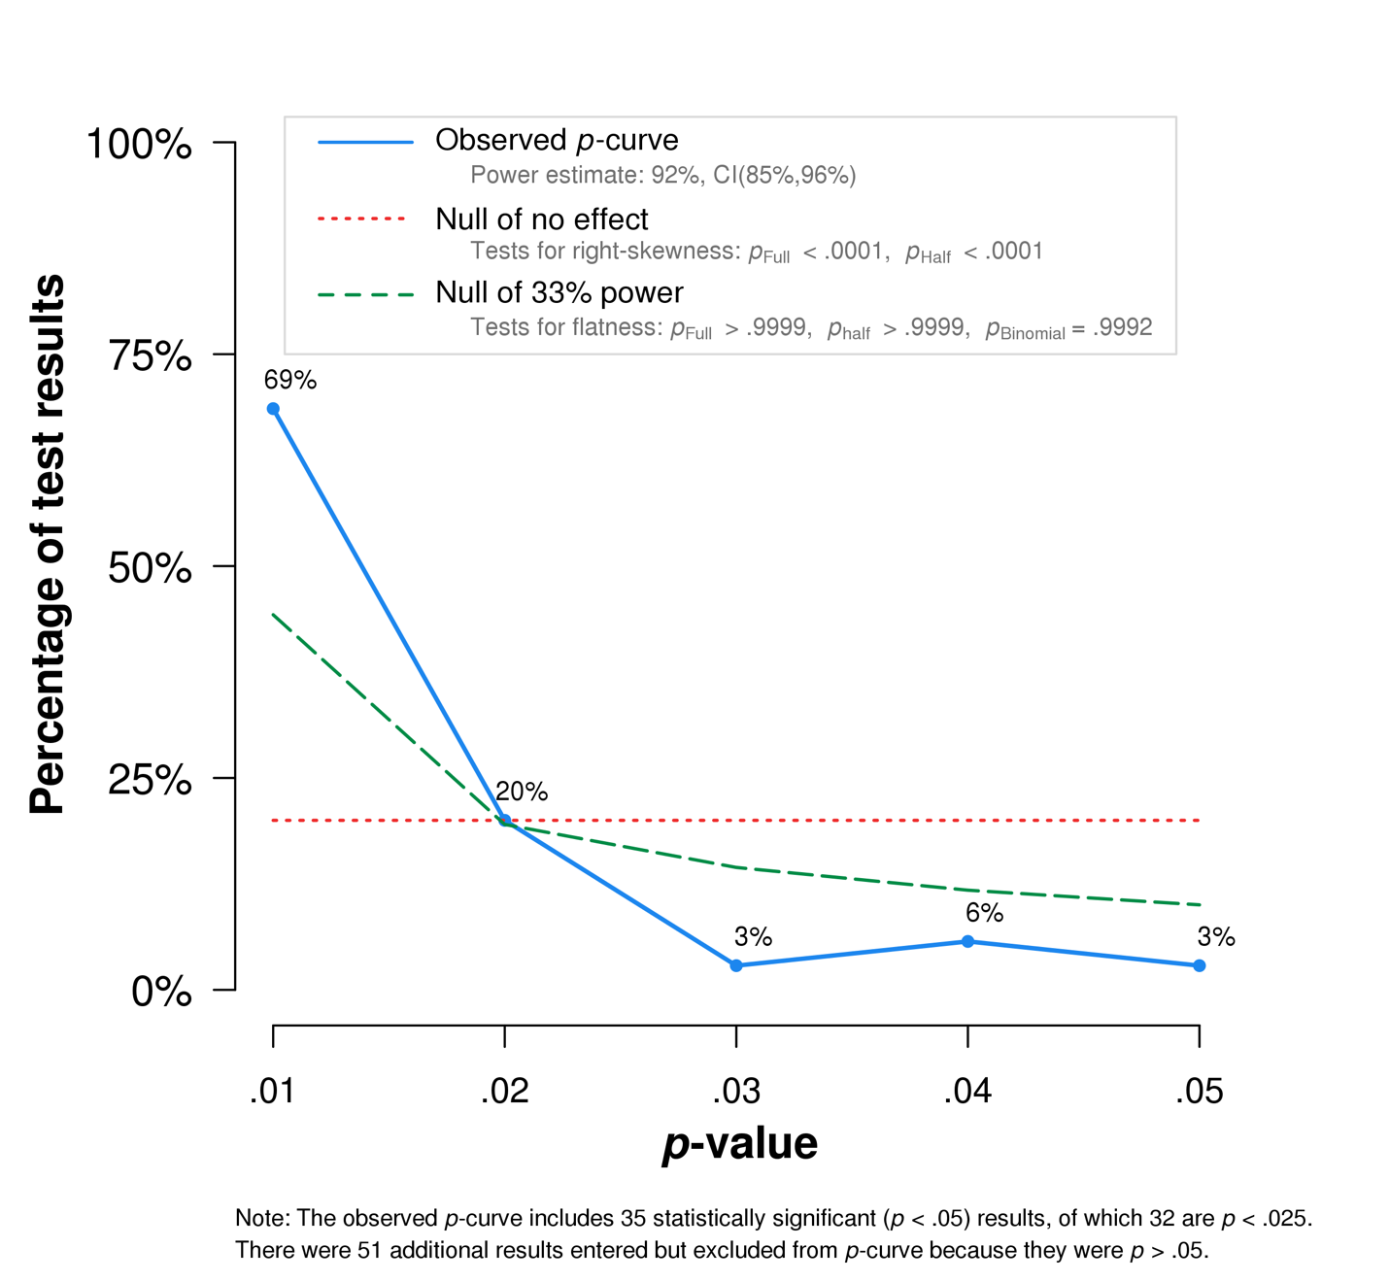

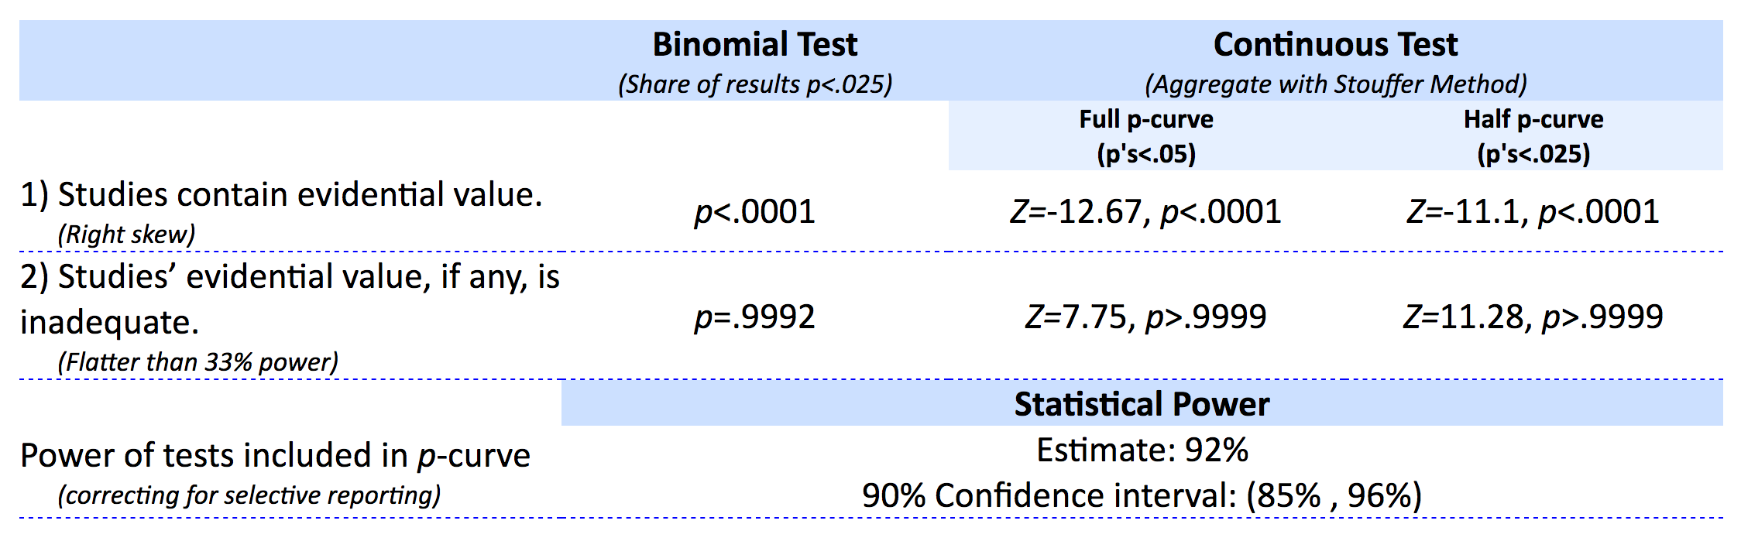

*Mixed PTSD Diagnosis*

|  |  |  |
| --- | --- | --- |
| Model | Fixed Effects | Random Effects |
| Overall Model | 0.351  [0.187; 0.515] | 0.351  [0.159; 0.543] |
| *Z* value | 4.19, *p* < .001 | 3.58, *p* < .001 |
| *p* – Uniform | 0.862  [0.279, 1.303] | - |
| PET | 0.331  [-1.767, 2.430] | - |
| PEESE | 0.310  [-0.777, 1.396] | - |
| Selection Models | 0.344  [0.119, 0.568] | 0.389  [0.068, 0.711] |
| Trim and Fill | [,] |  |

Homogeneity: *Q*(15) = 20.43, *p* = .156, *I2* = 26.6 [0.0; 59.8]

Power:

* Original study characteristics: *M* = .27, *SD* = .28
  + Percent over 80%: 12.5
* Based on random effects: *M* = .16, *SD* = .02
  + Percent over 80%: 0

*p* – curve

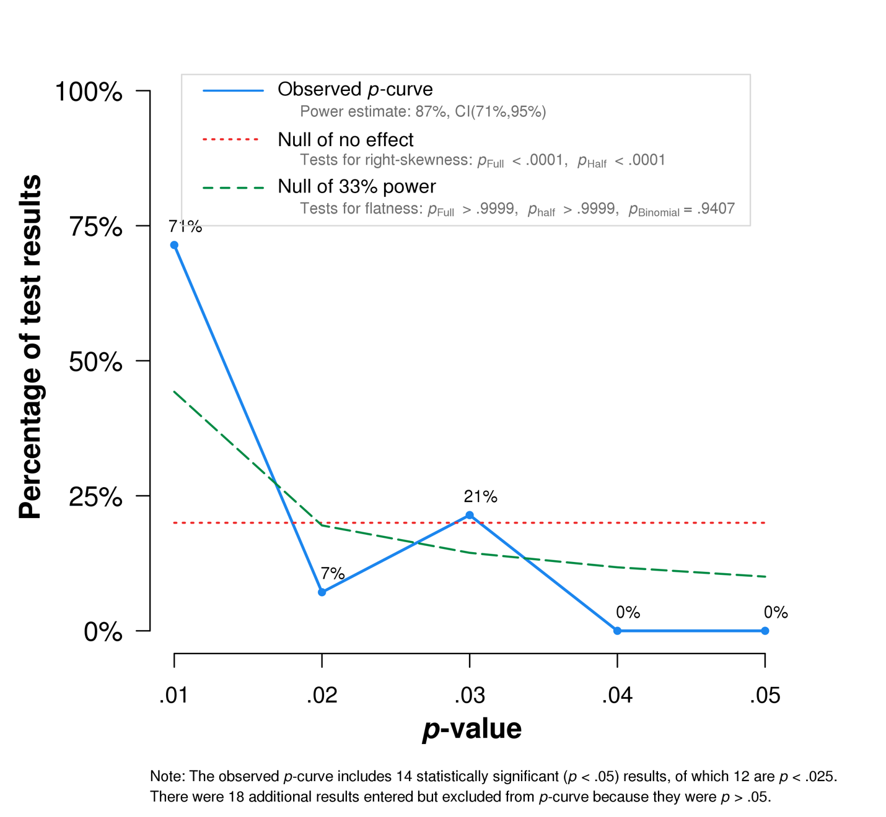

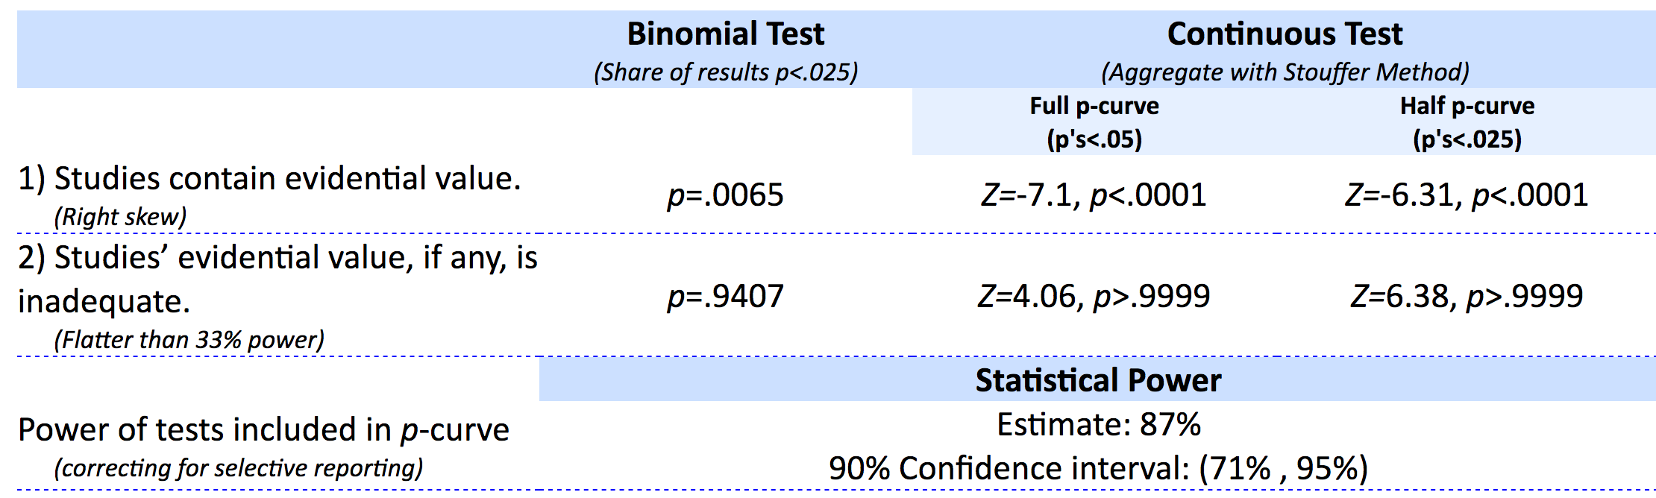

*Yes PTSD Diagnosis*

|  |  |  |  |  |
| --- | --- | --- | --- | --- |
| Model | Fixed Effects | Random Effects | Fixed  No Outliers | Random  No Outliers |
| Overall Model | 0.482  [0.426; 0.537] | 0.636  [0.479; 0.792] | 0.450  [0.394; 0.505] | 0.549  [0.411; 0.686] |
| *Z* value | 17.13, *p* < .001 | 7.96, *p* < .001 | 15.87, *p* < .001 | 7.79, *p* < .001 |
| *p* – Uniform | 0.807  [0.604, 1.046] | - | 0.733  [0.552, 0.951] | - |
| PET | -0.171  [-0.331, -0.011] | - | -0.029  [-0.194, 0.135] | - |
| PEESE | 0.233  [0.151, 0.315] | - | 0.277  [0.194, 0.360] | - |
| Selection Models | 0.490  [0.423, 0.557] | 0.694  [0.407, 0.982] | 0.455  [0.385, 0.525] | 0.570  [0.345, 0.796] |
| Trim and Fill | [,] |  | [,] |  |

Homogeneity with outliers: *Q*(44) = 325.65, *p* < .001, *I2* = 86.5 [82.8; 89.4]

Homogeneity without outliers: *Q*(42) = 235.57, *p* < .001, *I2* = 82.2 [76.7; 86.4]

Power with outliers:

* Original study characteristics: *M* = .58, *SD* = .38
  + Percent over 80%: 37.8
* Based on random effects: *M* = .78, *SD* = .26
  + Percent over 80%: 68.9

Power without outliers:

* Original study characteristics: *M* = .57, *SD* = .38
  + Percent over 80%: 34.9
* Based on random effects: *M* = .71, *SD* = .28
  + Percent over 80%: 46.5

*p* - curve

